The Furniture House
Furniture rental store

CASE STUDY 2024

An overview:

The Furniture House has operated for five years starting from a small store based in the village of Eccleshall in Staffordshire

Principally renting out Furniture to members but it has seen rapid growth and now has many branches throughout the Staffordshire area. It is felt that the organisations success is due to its excellent service provided to its members and the wide range of Furniture available to rent.

Furniture House currently has 200 staff working in 10 branches and so needs to be highly organised in its procedures for employing staff. A fictional employee registration form is provided in the appendix.

Every branch has a manager and several assistant managers called administrators. The manager is responsible for the everyday running of a branch and each administrator is responsible for co-ordinating a group of staff.

Staff reports are available for each branch detailing branch ID and address as well as contact details and staff details. See appendix.

Every branch of The Furniture House has a selection of Furniture for rental, each of which has a unique catalogue number, however, there are often several copies of each of the more popular Furniture items available in each store and so each PEICE OF FURNITURE has a unique FURNITURE number. An example of a listing of Furniture available at a store is given in the appendix.

Before a customer can hire a PEICE OF FURNITURE he/she must first become a member of The Furniture House by completing a member registration form (example in appendix). The Furniture House currently has approximately 10,000 members, some of whom are registered at more than one branch having filled out another customer registration form for each branch they belong to.

The manager can run a report to see the members registered with each branch. (Example in appendix). A registered member can rent up to 10 pieces of Furniture at one time from each store they are registered with. On each rental a rental form is completed. (Example in appendix).

The Furniture House has seen rapid growth but the problems in managing the data being generated by operations has also grown enormously. The Managing Director has requested that a database system be created to cope with the processing of the data into useful information.

You are part of a team of database developers that have conducted interviews with employees of ‘The Furniture House’ and you will use this information to define both a mission statement, systems boundary model and user requirements specifications.
Interview with: Managing Director (MD)

Date conducted: 12/12/2022
Interviewer: Database developer (DD)
DD | What is it that The Furniture House does?
MD | We rent out Furniture to our members that are registered in our branches.
DD | What will a database do for your organisation?
MD | The business has grown so much that we cannot cope with our success. Several branches have recently opened hiring a larger and larger selection of Furniture to a growing number of members. But now I have problems keeping my finger on the pulse of the organisation. I want to know what is happening day to day and to have an overview of the organisation so that I can see trends and growth patterns. I feel the level of service we offer customers is falling as is the cooperation and sharing of information between the branches.
DD | What makes you think a database can help you solve your problems?
MD | If we do not solve the problems, we have with the paperwork the business will suffer. We need to speed up the way we process paperwork, we need to automate the handling of data and we need the branches to start working together. Isn’t this what databases do?

DD | What is it you do for the company?
MD | My job is to grow the company and ensure we provide the best possible service to our members
DD | What is it you do on a day-to-day basis?
 | I watch over the running of each and every branch by our managers. I try to get them to work together and share information about Furniture and members. I also monitor the Buyer for Furniture House that is the person responsible for buying Furniture for all our branches. I try to call the branch managers at least once a month in order keep a high profile. I also organise occasional Training courses for staff.
DD | What is the sort of data you work with?
MD | Everything I need to have access to is everything The Furniture House uses or generates in the way of data, including staff details, FURNITURE details, rental details, members, suppliers and FURNITURE orders, what Furniture are being sold. Yep… everything, oh but let’s concentrate on the rentals rather than the sales.
DD | What are the reports that you use?
MD | I get information from reports on staff, FURNITURE in stock, FURNITURE rentals, member listings, FURNITURE suppliers and orders.
DD | What is the service The Furniture House provides to its members?
MD | We are the best and most competitively priced PEICE OF FURNITURE rental service in the North Midlands!

DD | What type of security do you want for the database system?
MD | I do not want our competitors to see our data on members and their rentals. Staff should see only the data they require to have to do their jobs.
DD | Is there any particularly sensitive data that should be seen by only certain members of staff?
MD | As before, staff should only see the data they need to do their job.
DD | What history do you want to keep?
MD | I want to be able to keep all members details for a period of 6 years after their last PEICE OF FURNITURE rental so we can mailshot them and inform them of the latest promotional offers in order to attract them back. I also want 6 years of rental info so that I can analyse the most popular Furniture by age groups, etc...
DD | What are the networking and shared access requirements of the system?
MD | All branches should be networked to our headquarters in Eccleshall, allowing staff to access the system from wherever and whenever they need to. At most branches I would expect at most three staff to be accessing the system at any one time but remember how many branches we have and that we are going to grow. But I do not want any restrictions on how or when the system can be accessed unless it is financial.
DD | What type of protection from systems failure or data loss do you want?
MD | The absolute best. The database will become critical to our operations, so if it goes down we go with it…. Ok, let’s back up the data every evening when the branch closes? Yes?
Interview with: Managing Director (MD)
Date conducted: 12/12/2022
Interviewer: Database developer (DD)

Interview with: Branch Manager (BM)

Date conducted: 13/12/2022
Interviewer: Database developer (DD)
DD | How would you describe your job?
BM | I am the manager, meaning I watch over the day to day running of one branch of The Furniture house. I ensure we provide the best service to our members.
DD | What kind of things do you do on a typical day?
BM | I make sure the branch has the right type and number of staff on duty all the time. I watch the hiring of Furniture to make sure we have the right selection appropriate to our membership. I do not buy the Furniture, that done by the company buyer but I do check the registering of new members and see over the hiring of new staff.
DD | What is the data you work with?
BM | I work with data on the staff, the Furniture, what is being rented and member details.
DD | What is it you need to monitor on a day-to-day basis?
BM | Staff, rentals, stock and members, oh yes and the Furniture that are sold rather than rented.
DD | How would you describe the service that The Furniture House provides?
BM | We give the best value FURNITURE rental service in the Midlands.
DD | What type of data do you hold on staff?
BM | Name, position and salary, start date, finish date, yes and every member has a staff ID.
DD | What things do you do with this data?
BM | I enter new staff details when they start and the date they finish. I need to keep details of staff up to date and generate reports; listing name, position and salary of each staff member at my branch. I also need to allocate staff supervisors to look after staff. On occasion I need to talk with other branches, so I need their managers’ details.
DD | What transactions frequently run on the database?
BM | Members phone or call in asking about the availability of a certain PEICE OF FURNITURE but most often we are renting out and returning Furniture.
DD | What transaction do you consider critical to the operation of the business and when do they run?
BM | Searching for particular Furniture by style, age, colour etc. Renting out and returning Furniture are the essential transactions. All run each and every workday.
DD | Are there periods of high or low activity?
BM | Things are quieter in the mornings but get busier as the day progresses, with 6-9pm being the busiest. In fact we have to double the staff working during the busy periods on Fridays and Saturdays.

Interview with: Administrator (Admin)

Date conducted: 14/12/2022
Interviewer: Database developer (DD)

DD | How would you describe your job?
admin | I look after a small team of staff dealing directly with our members in renting Furniture
DD | What Kind of things do you do on a typical day?
admin | I give the staff their jobs to do; such as restocking selves, processing paperwork and dealing with members. I also answer members questions about Furniture for rent. I oversee the renting out and return of Furniture. I ensure that members’ details are kept up to date as well as signing up new members.
DD | What is the data you work with?
admin | I work with data on the staff, the Furniture, what is being rented and member details.
DD | What reports do you use?
admin | Reports on Staff and stock, but the MD wants to know why we can’t search our FURNITURE catalogue to find particular items by companies, colours and sizes.
DD | What service does Furniture House provide?
admin | We give the best value FURNITURE rental service in the Midlands

Interview with: Buyer (Buy)

Date conducted: 13/12/2022
Interviewer: Database developer (DD)

DD | How would you describe your job?
Buy | My job title is buyer and I am responsible for purchasing all the Furniture we rent out, oh yes I do that for all of the branches
DD | What Kind of things do you do on a typical day?
Buy | Working with the individual branch managers and FURNITURE suppliers I respond to managers requests for certain Furniture. It is my job to make sure we get the best possible deal for ‘The Furniture house’ when purchasing.  This depends upon managers doing their homework and only requesting Furniture that will be rented by their members, as I do not want to order Furniture that a branch does not rent or does not have available Furniture that members want. When time allows, I do check by monitoring the renting of Furniture at each branch to make sure they have an appropriate range of Furniture.
DD | What is the data you work with?
Buy | I require access to data on Furniture, rentals, orders branches and suppliers.
DD | What reports do you require?
Buy | Reports on what orders have been placed on Furniture, what Furniture are in stock, what is being rented, members at each branch and across all branches.
DD | What sort of things do you need to keep track of?
Buy | I have to have current, timely, up-to-date information on orders I have placed as it is important that suppliers, we use should not let us down. I need to understand the stock situation and FURNITURE rentals at each branch as I do not want to order a FURNITURE that will not be rented.
DD | How would you describe the service that The Furniture House gives its members?
Buy | We provide the selection of Furniture for rentals at the best possible price.
Interview with: Assistant (Assist)
Date conducted: 13/12/2022
Interviewer: Database developer (DD)

DD | How would you describe your job?
Assist | My job title is assistant. I deal directly with our members in providing a FURNITURE rental.
DD | What Kind of things do you do on a typical day?
Assist | All sorts of things from answering questions about Furniture for rent; like “Do you have such and such a desk?” I process the renting out and return of Furniture. I restock the branch with Furniture that have been returned and I also file paperwork when required.
DD | What is the data you work with?
Assist | Data on Furniture, rentals, and members.
DD | What reports do you use?
Assist | I need access to the stock lists, and I like to keep up to date with new releases.
DD | What sort of things do you need to keep track of?
Assist | Simply what Furniture are available for renting and what is coming out soon. I am frequently asked by customers for furniture from upper market outlets or which have appeared in Hello magazine
DD | How would you describe the service that The Furniture House gives its members?
Assist | On a daily basis I answer questions such as; “What Furniture do we have in a price range”, “What colour and size is the ….” Just the sort of thing a furniture buff picks up, if I do not know the answer usually one of the team does.

System specifications

The team have identified the following specifications:
Initial database size
- There are about 1,000 PEICE OF FURNITURE and 10,000 Furniture items available for rent distributed over the 10 branches with an average of 400 and a maximum of 1,000 Furniture for rent at each branch.
- There are approximately 200 staff working across all of the branches. There are an average of 10 staff and a maximum of 20 staff working at each branch.
- There are approximately 10,000 members registered across all branches. There is an average of 100 and a maximum of 150 members registered at each branch.
- There are about 60,000 FURNITURE rentals across all branches.
- There is an average 6,000 and a maximum of 15,000 FURNITURE rentals at each branch.
- There are about 30 PEICE OF FURNITURE suppliers and 250 PEICE OF FURNITURE orders.

Rate of database growth
- About 20 new PEICE OF FURNITURE are added each month and up to 10 copies of each PEICE OF FURNITURE are added on average each month.
- About 100 individual Furniture are deleted from the records each month due to being lost or damaged and unplayable.
- On average 2 members of staff join and leave the company in a month with the requisite employee records being altered.
- About 100 new members register at branches each month.
- About 500 PEICE OF FURNITURE rentals are recorded across the 10 branches each day.
- Records on rentals are deleted after 6 years
- About 10 new PEICE OF FURNITURE orders are placed each week, details being destroyed after 6 years.

Searches: types and average number
- Branch details: about 2 per day.
- Staff details: about 5 per day.
- FURNITURE details: about 500 per day Sunday to Thursday increasing to 1,000 on Friday and Saturday.
- Searching for member details: about 50 per day.
- Per day increasing to 2,000 per Friday and Saturday.

Networking requirements
- All branches to be securely networked to a centralised database located at the organisations main office in Eccleshall.
- The system should allow at least two people concurrently accessing the system at each branch.

System specifications contd.

Performance
- During opening hours, but not peak periods, a sub one second response time on all single record searches.
- During opening hours, but not peak periods, a sub 5 second response time on all multiple record searches.
- During opening hours, but not peak periods, a sub one second response time on all updates and saves rising to sub five seconds during peak periods.

Security
- Password protection on the database.
- Each user should be assigned database access rights as appropriate to them doing their job adequately.
- Staff should only see the data that is required for them to do their job adequately.

Backup and recovery
- Database should be backed up each evening at close of business.

User interface
- The user interface should be menu driven with appropriate on line help.

Legal stance
- Data protection act should be adhered to along with all other UK legal requirements.

The Furniture House
Branch Members Report 1.05
Branch ID: Branch Address:

Telephone Numbers(s):

Member Number Name Address Join Date

M12345 John Green 16 Brockley Sq, Hanley, ST1 5LY 12/12/2006
M14234 Peter Brown 127 Pea Lane, Hanley, ST1 4JH 13/12/2006
M12432 Ron Davis 83 York Street, Hanley, ST1 5ET 26/01/2006

rental form 1.06
Member Number: Branch ID:

Member Name: Branch Address:
Stock Title Rental Date Out Date In Total
Number cost

18828 Ikea malm bed 40 per month 16/07/2022 18/012/2022
16253 Habitat Kristopher Bed 30 per month 19/07/2022 20/01/2023

The Furniture House

Member Number:
(Enter if known)
Full Name:
Member Address:
Date Registered:

Branch ID:
Branch Address:
Registered By:

Member registration Form 1.04
The Furniture House

rental store

stock report 1.03
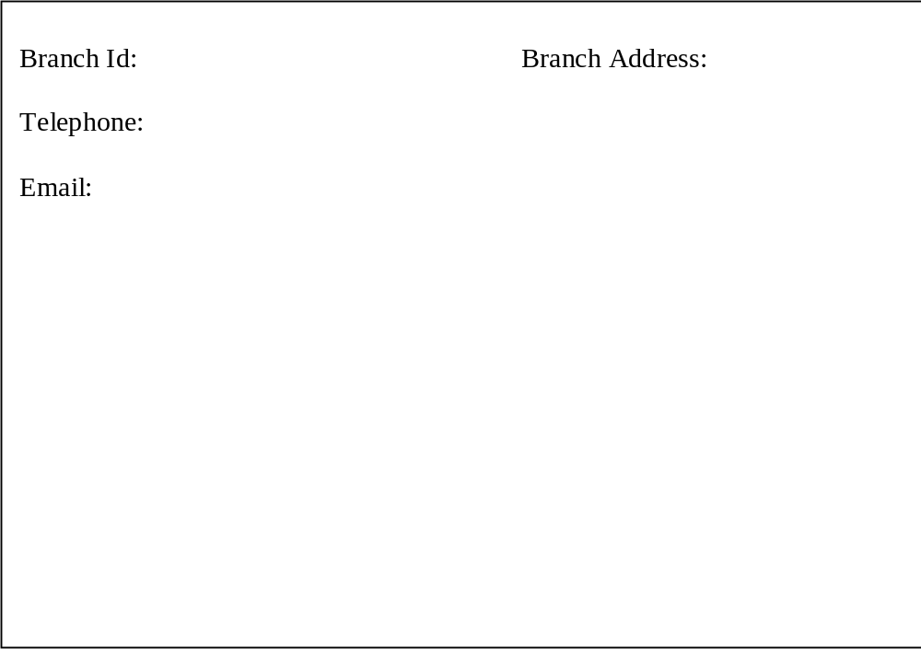

Stock Item title Title Type Hire
Number Number cost

The Furniture House

Notice the use of page numbers indicating that many staff can work at a branch and that reports require correct formatting indicating this

Staff report 1.02

Branch ID: Branch Address:

Telephone:

Email:
B010
01785 850166

Castle St Eccleshall
Stafford, Staffordshire
ST21 6DF
T 01785 850300
Staff Number: Name: Position:

S0090 John Green Manager
S0110 Cal Jones Administrator
S0120 Clare Smith Administrator
S1060 Chris Logan Assistant
S1070 Anne Walters Assistant
S1080 Jan Round Assistant
Page 1 of 2
The Furniture House

Staff registration form 1.01

Staff ID:

First Name:

Surname:

Position:

Salary at start date:

/ /
Start Date

Branch ID:

Branch Address:

Telephone:

Email:

The Furniture House

